**Case Study: How Does a Bike-Share Navigate Speedy Success?**



**Submitted by :** Bhargav Shamuvel Gurav

**Problem statement:** To maximize the annual membership of Cyclistic

**About Cyclist**:

* A bike-share program that features more than 5,800 bicycles and 600 docking stations.
* Cyclistic sets itself apart by also offering reclining bikes, hand tricycles, and cargo bikes, making bike-share more inclusive to people with disabilities and riders who can’t use a standard two-wheeled bike.
* The majority of riders opt for traditional bikes; about 8% of riders use the assistive options. Cyclistic users are more likely to ride for leisure, but about 30% use them to commute to work each day.
* **Lily Moreno**: The director of marketing and your manager. Moreno is responsible for the development of campaigns and initiatives to promote the bike-share program. These may include email, social media, and other channels.
* Cyclistic’s finance analysts have concluded that annual members are much more profitable than casual riders
* Moreno believes there is a very good chance to convert casual riders into members.
* Moreno has set a clear goal: Design marketing strategies aimed at converting casual riders into annual members

**Dataset:**

Dataset link : <https://divvy-tripdata.s3.amazonaws.com/index.html>

(Note: The datasets have a different name because Cyclistic is a fictional company. For the purposes of this case study, the datasets are appropriate and will enable you to answer the business questions. The data has been made available by Motivate International Inc. under this [license](https://ride.divvybikes.com/data-license-agreement).)

**Process steps :**

1. A clear statement of the business task

2. A description of all data sources used

3. Documentation of any cleaning or manipulation of data

4. A summary of analysis

5. Supporting visualizations and key findings

6. Top three recommendations based on your analysis

Phase 1:

**Statement ( Business Task)**: How to maximize the annual membership of Cyclistic.

Phase 2:

As we have discussed above about dataset. It is stored in .csv format and for each month there is a separate file. The dataset is licensed and provided by Motivate International Inc. Thus data can be trusted. Still there are some rows in the .csv file where there is no entry done in some cells. So we have to either find the answer by asking stakeholder or we just need to do analysis excluding those rows.

Phase 3:

1. first we need to read all data and collect it in dataframes variables.
2. Then we combined all data to one variable and saved it in a csv file
3. Deleted some not required columns, like start_station_id, end_station_id
4. we cannot delete null rows as they have membership data and ride details.
5. Calculated ride_length in minutes by time difference in start time and end time of ride.
6. Calculated what is the weekday of ride i.e. Sunday, Monday…..

Phase 4:

Number of casual members and subscribers

member_casual

casual 2529005

member 3066058

Number of rides on weekdays :

( Note: here 0 = Sunday, 1 = Monday, 2 = Tuesday, 3 = Wednesday, 4 = Thursday, 5 = Friday, 6 = Saturday)

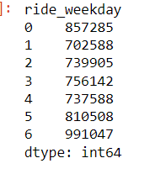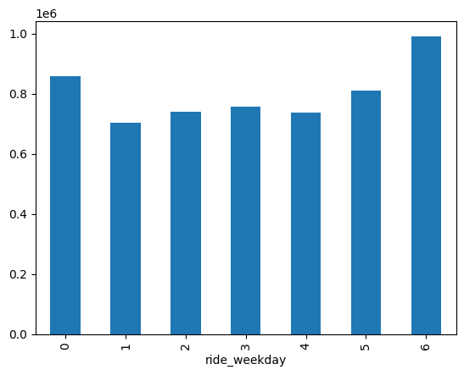

Number of rides done by both type of members and on what weekday

member_casual ride_weekday

casual 0 481143

1 286376

2 274392

3 278950

4 286064

5 364080

6 558000

member 0 376142

1 416212

2 465513

3 477192

4 451524

5 446428

6 433047

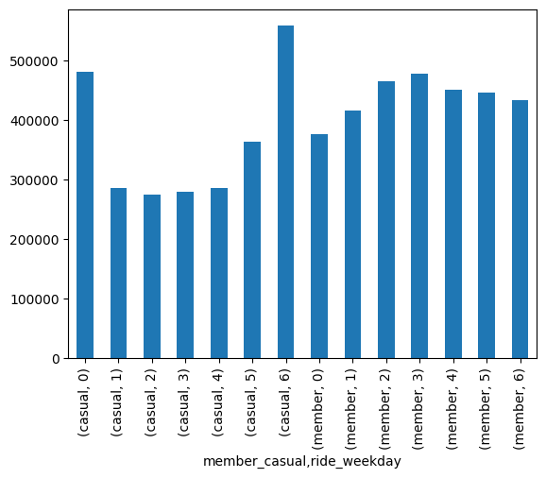

Average ride length in minutes by members

member_casual

casual 31.511207

member 13.143513

Name: ride_in_min, dtype: float64

Average ride length on weekdays

member_casual ride_weekday

casual 0 37.071297

1 31.385556

2 27.482186

3 27.166890

4 27.212568

5 29.858663

6 34.216419

member 0 15.164874

1 12.757724

2 12.297906

3 12.329668

4 12.286835

5 12.835447

6 14.775191

Phase 5:

* we see casual members ( 2.5M) are nearly equal to subscriber members(3M) .
* Rides are made on mostly Saturday and Sunday.
* We see rides made by subscriber on each day are very much greater than casual riders.
* But on Sunday and Saturday rides made by casual members are very much greater.
* It clearly indicates that casual members prefers rides on weekends. That could be because of their job that has holidays on weekends.
* When we deeply look at the average ride length of both type of members, then we come to know that casual members’ ride length on every day of week has great difference than subscriber riders.
* We should be more focusing on casual members as even if they are less in number but more revenue is getting made by them.
* We should be creating new schemes, starting from discounts on rides on weekends. And some schemes for only subscribers so that casual members can convert their membership.